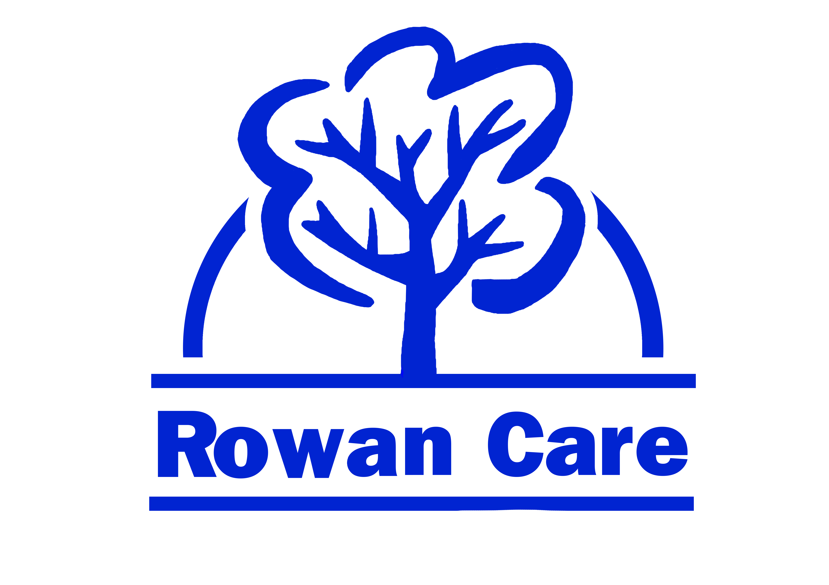

JOB DESCRIPTION

Job Title: Care Worker
Salary Grade: From £8.50 per hour (reviewed annually)
Responsible to: Supervisor/Manager
Location: Various in the Denbighshire area
Hours of work: up to 37.5 (flexible)
Line Management Responsibility: None

Main Scope of the Post:

To work flexibly within a home based environment to provide help and support to service users.

Key Responsibilities:
Work in partnership with other professional agencies to provide help and support to service users.

Key Tasks:

- Assist with personal care of service users
- Undertake light household duties and prepare meals
- Escort service users to shops, appointments etc as directed
- Assist with the moving and transfer of service users within the home using appropriate equipment
- To arrive punctually and undertake tasks as defined in the Personal Plan
- Report any concerns to Line Manager
- Maintain confidentiality at all times
- To work with line manager and other members of staff as part of the team.
- Undertake training as necessary
- Attend staff meetings
- Comply with current policies and procedures particularly Health & Safety & Equal Opportunities
- Use appropriate safety equipment (Disposable gloves and aprons etc) for all care tasks
- Any other duties commensurate with the scale of the post

Notes:

Rowan Care reserves the right to alter the content of this job description, after consultation to reflect changes to the job or services provided, without altering the general character or level of responsibility.
The duties described in this job description must be carried out in a manner which promotes equality of opportunity; dignity and due respect for all employees and service users and is consistent with Rowan Care’s Equal Opportunities Policy.
This job description is not necessarily an exhaustive list of duties but is intended to reflect a range of duties the post-holder will perform. The job description will be reviewed regularly and may be changed in the light of experience and in consultation with the post-holder.

